### PROJECT NAME: Monitoring Incident States for Effective Management

TEAM MEMBERS : M.KARTHIK,A.AJAI,V.VEERARAGAVAN,

R.SATISH.

Category: ServiceNow Administrator

Skills Required:  
Reporting and Dashboards

Project Description:

Our organization needs a report for the incident management process. This report will help assignment group managers monitor the current state of incidents assigned to their teams. The focus will be on incidents that are in the states of "New," "On Hold," and "In Progress." By providing this information, managers can prioritize and address issues promptly, ensuring efficient incident resolution and improving overall service quality.

**Activity-1:**

1. Open service now developer Instance
2. Click on All

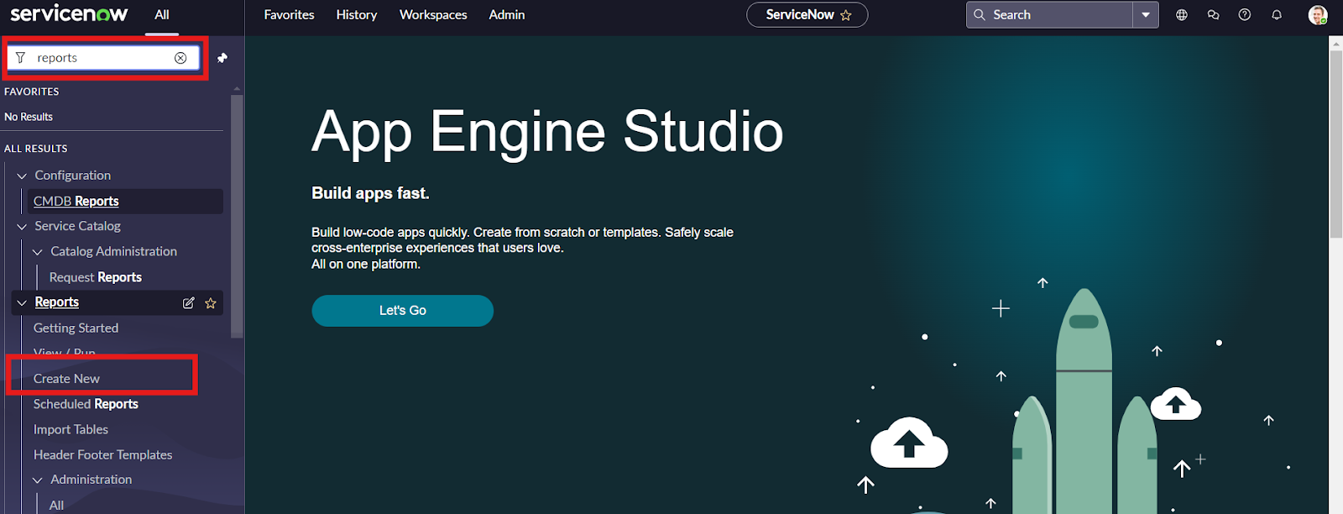

4.Search for reports and click on create new

5.Give the report name

6.Select source type as table

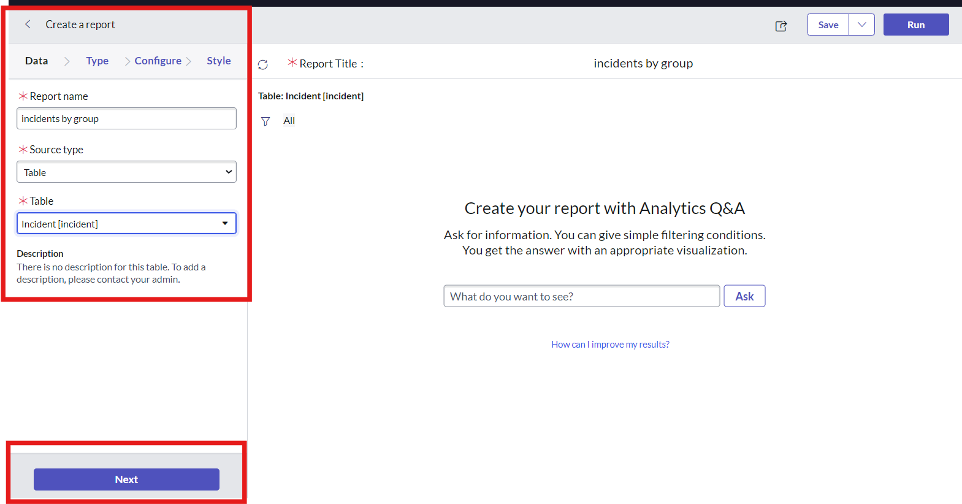

1. Select table incident
2. Click on next
3. Select type as pie chart

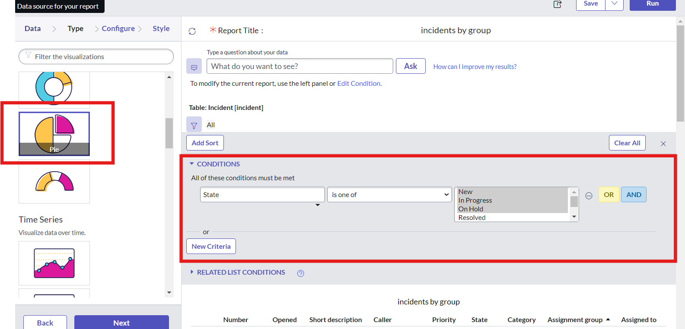

9.Click on funnel icon and give condition  
Field : state  
Operator : isoneof  
Value : new,onhold,inprogres

10.Click on next

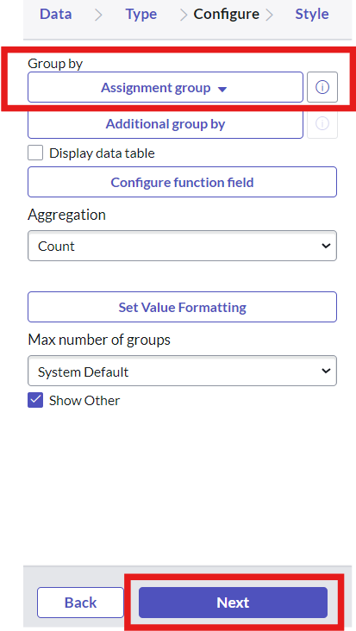

11.Group by assignment group and click on next

12.Click on save

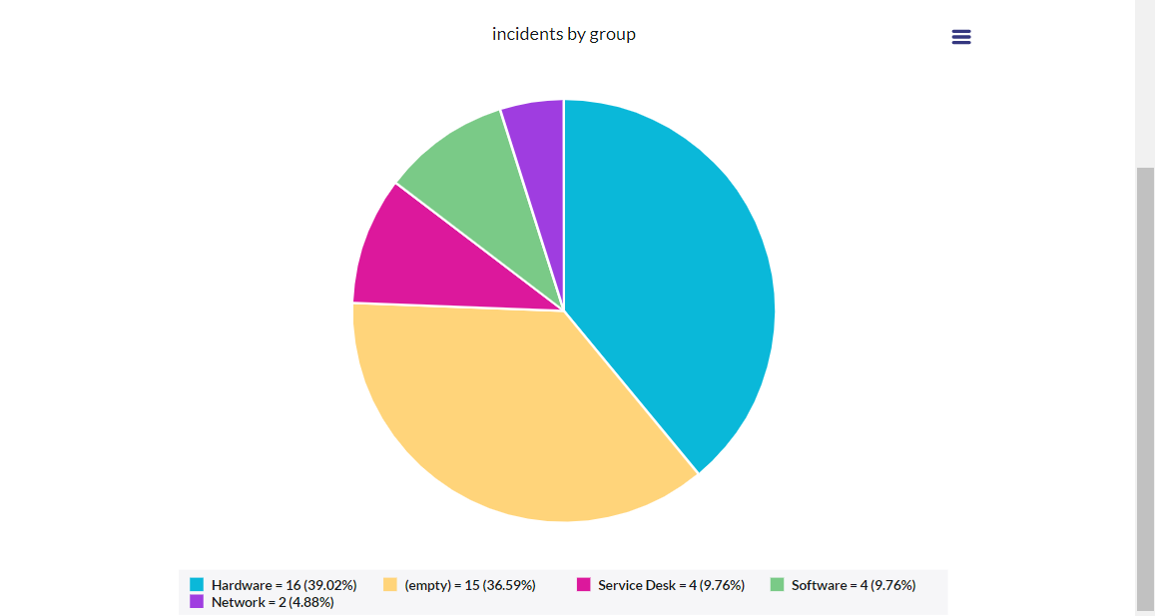

13.Click on run

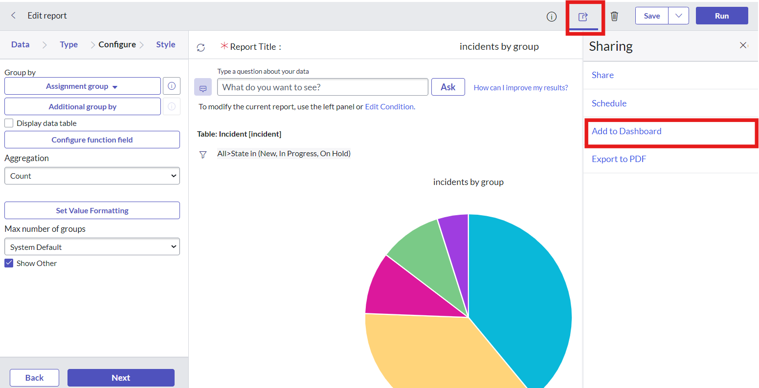

14.Now add report to dashboard

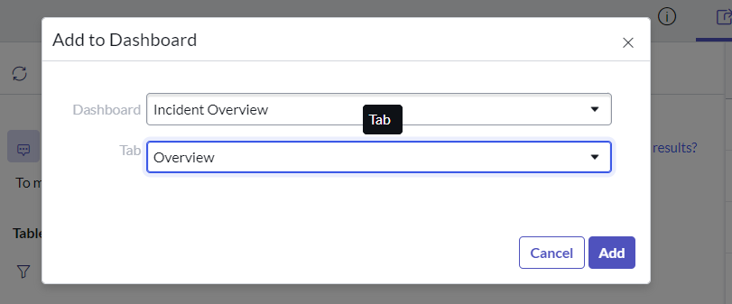

15.Give the dashboard and title name

16.Click on add

17.New Dashboard was added to the incident overview folder

RESULT :

1. Open service now PDI instance
2. Click on all
3. Search for dashboard
4. Select dashboard under self service

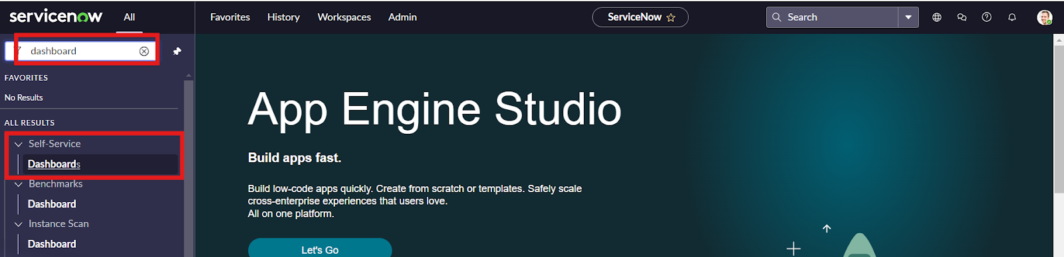

5.In the search bar enter incident

6.Select incident overview

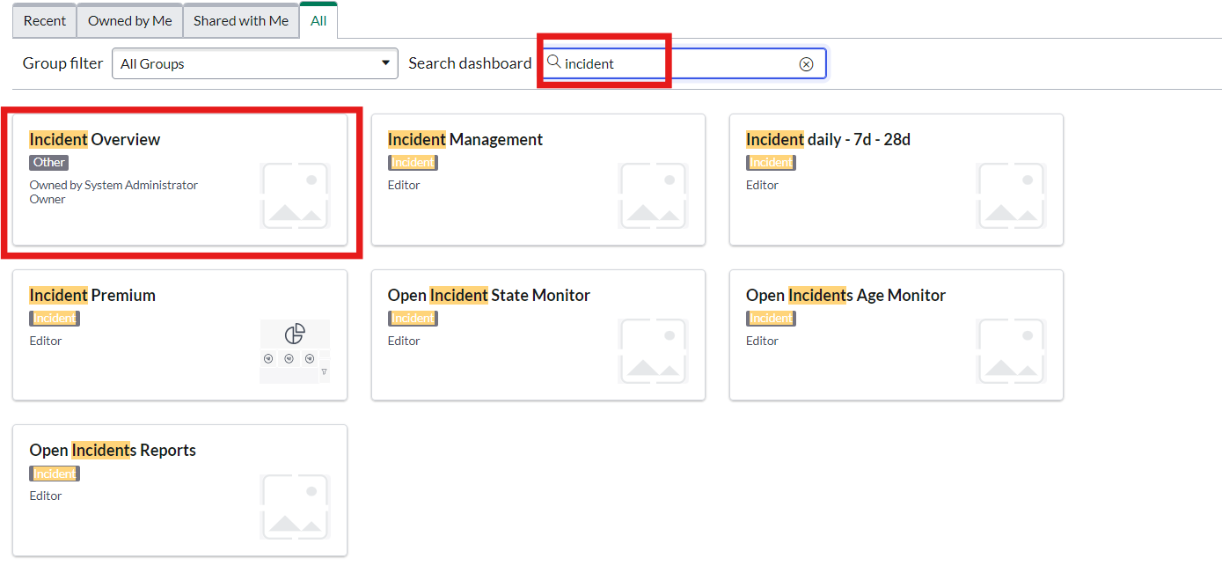

Here we can access the dashboard we create

